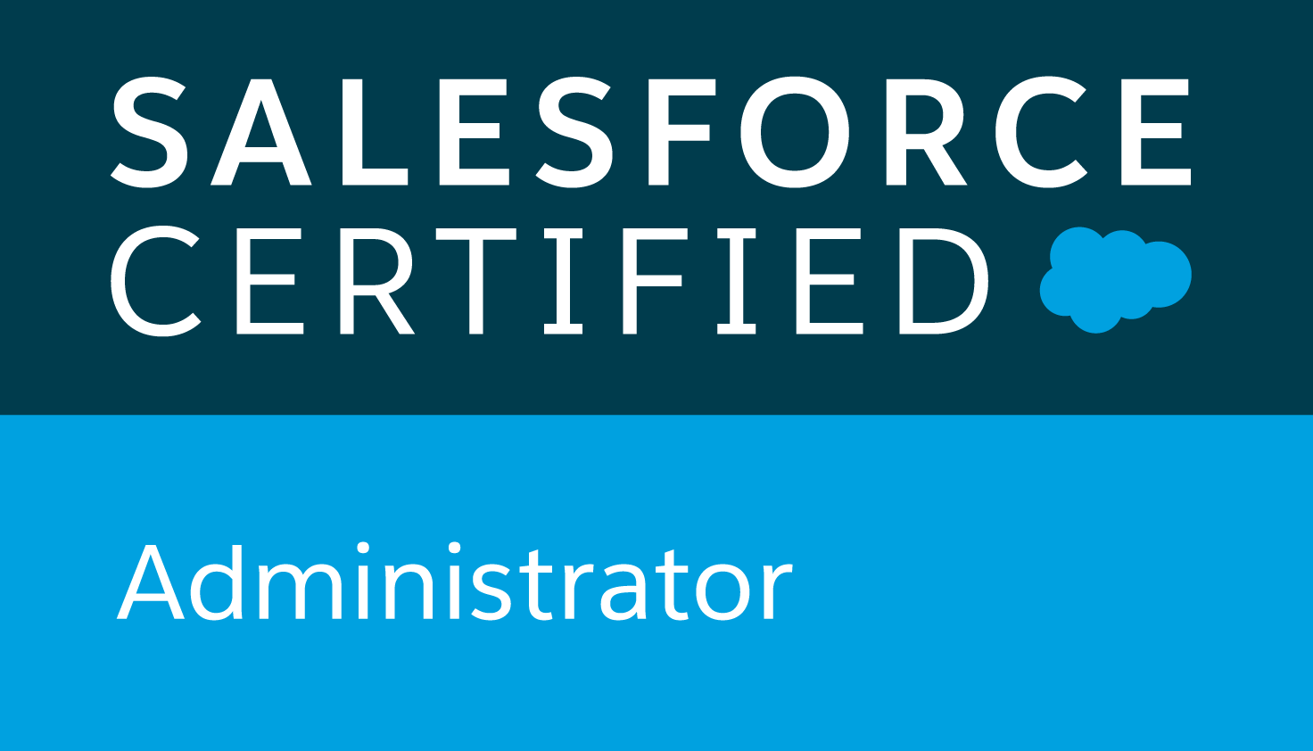
Deepak K Rana
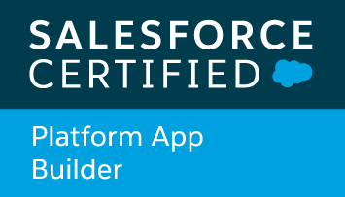
London, United Kingdom • +44(0) 7443340401
deepak@crmmates.com • Skype: deepakrana
Linkedin: https://www.linkedin.com/in/amforma • Trailhead: https://trailblazer.me/id/dkrana
Profile

Salesforce CRM, Sales cloud, Service, Marketing, Financial cloud consultancy and Data Integration expert along with 15 years of experience in IT Pre-sales, IT consultancy, strategizing, architecting, administrating and customizing CRM, business analysis, UI interface conceptualization, project management, web portal development, and product development. Able to convert ideas into realities. Posses both technical and functional aspects to develop solutions. Worked on marketing cloud automation. Developed antivirus software - Rainbow Antivirus in collaboration with API connections with Kaspersky Lab.

Relevant Knowledge, Skills, and Training
Salesforce CRM • Sales Cloud • Service Cloud • Marketing Cloud • Financial Cloud • KPIs • Analytics • Data Analysis • Data Loader • Business Analysis • RFIs • RFPs • Roadmaps Development

Education

MBA – Master of Business Administration August 2013 - 2014
HULT INTERNATIONAL BUSINESS SCHOOL—London, United Kingdom
World's most international business school. Top 10 FT ranking for international business and experience.
- Gained insights on global companies’ case studies such as Boeing 7E7, Disney Land and more
- Action project with Financtieri where provided live consultancy to client to optimize their business performance by 20% by 2020 – lead historical data analysis task as part of 6 team members
- Major in digital marketing, and had done case studies on McDonalds, Targus & Zalando

BCA – Bachelor of Computer Applications - 2003 April, 2000 - 2003
Guru Nanak Dev University – Amritsar, Punjab, India.
- Gained knowledge in computer networks, applications, graphics, programming language, database development, numerical methods and management communication skills

Professional Experience

Eviden (ATOS SYNTEL LTD) —London, UK Mar 2021 – Current
Eviden (formally Atos Syntel) is a subsidiary of Atos and a multinational provider of integrated technology and business services. Atos is a sponsor of Olympics from past 18 years.

Senior Salesforce Technical Lead – Currently leading NHS on implementing overall salesforce project

- Leading a project with NHS on Barnet, Enfield and Haringey boroughs on mental health solution
- Worked on data migration project with MOD – Ministry of Defense.
- Led Cancer Research UK (CRUK) project on technical development on Salesforce
- Designing ERD diagrams, implementing solution designs and approaches with data mapping docs
- Led integration project on salesforce with Govt org - Student Loan Company(SLC) on inbound and outbound correspondence
- Implemented complex reporting & OwnBackup solution for National Trust project
- Evaluating business processes by coordinating with various stakeholders across the company to understand business objectives to design technical documentations
- Building E2E documentations with architectural design on Salesforce with help of integration using MuleSoft and end systems known as LOB – Line of businesses
- Lead area of project on inbound correspondence using Mulesoft and Alfresco
- Helping developers on day to day coding challenges and Gitlab code repositories and version controlling along with regularly updating Jira & Confluence updates
nCino global ltd —London, UK Feb 2020 – Sept 2020
Leading banking operating system on salesforce, worked on client Barclays bank on CBILS & BBLS project

Senior Enterprise Implementation Consultant – Worked on Barclays bank project on implementation digital journey on CBILS and BBLS loans as part of architecture team

- Implemented salesforce based nCino Banking Platform on CBILS and BBLS project for Barlcays bank
- Implemented & Lead DocuSign integration for BBLS and CBILS clients with influence of over £7 Billion loan amounts
- Supported day to day activities happening on salesforce implementation plans, daily briefings
- Data mapping on salesforce to salesforce org setting at complex corporate level integration
- Built validation rules on various important fields and data points
- Built workflow rules to move loan stages after documentation validaitons
- Handled support team trainings and KT sessions
- Arranged and delivered demo presenations on roap-maps and customer journeys
- Internal webinars on knowledge sharing sessions
- Cooridnated with teams on salesforce system architecture design and improvement meetings
- Helped company to have strategic partnership with DocuSign as digital signature provider
- Managed client stakeholder meetings on security, range of approvals and project updates
- Contributed on the project milestones setup on smartsheets
- AWS integrations handling on various DB integrations on architecture design

World First UK Ltd —London, UK April 2019 – Nov 2019
Leading FX bank owned by Alibaba Group, provided consultancy under umbrella company CRM Mates Ltd

Salesforce Consultant & Architect– Lead project on Salesforce CRM on both Sales, Service and Marekting cloud. Involved in initial plan team for implementing SFDC with various clouds

- Conducted workshops on analyzing the initial requirements and idenfied with priority levels
- Designed analysis documentantion on the form of RFP/RFI
- Presented the presentation to the higher stakeholders to take feedbacks and improved plans to develop an actionable project
- Responsible for implementing and configuring sales cloud, service cloud and marketing cloud
- Lead the data migration project from Oracle Eloqua to Salesforce marketing cloud
- Managed business processes, data integrity, 3rd party integrations
- Developed KPIs and Dashboards, coordinated technical development teams, performed QA analyses
- Involved in CTI implementation project with 8x8 integration
- Trained colleagues on using appropriate opportunity stages and helped them organize workflow using Outlook integration
- Maintained communication with salesforce account manager
- Regularly had agile based meetings on weekly basis to update progresses on project
- Updated confluence pages with latest project development and release updates
- Managed slack communicated tool to create streamline communication between cross teams
- Data analysis using PowerBI and Tableau, along with data updated using Dataloader/MuleSoft
- Omnichannel integration, cases assignment rules implementation on service cloud and sales cloud
- AWS integration for the data storage and data analysis integrations to intelligence tools

Various Clients: Fly Victor • PBA Singapore • Tony Blair Faith Foundation (TBFF) • Hi Inc • Directory Guys • Commend UK & more.

SALESFORCE CONSULTANT & ARCHITECT—London, United Kingdom APRIL 2015 – April 2019
Privately providing consultation to clients such as:

Salesforce CRM/Data Consultant - Involved in providing consultation on IT projects using Salesforce and Google Analytics. Analysing data using Excel, KPIs, Tableau, Salesforce and Custom reports
- Performed initial assessment on the project requirements, created project plans, conducted workshops, brain storming sessions, implementation plans & Data integration projects
- Implemented roadmaps, KPIs, business strategy and planning, vision and objectives setting
- Cases management to implement service and sales cloud assignment rules
- CPQ implementation project with Commend UK & Conga Implementation for various clients
- Provided Salesforce customization support using workflows, triggers, fields updates, custom reports, page layouts, record types and data administration etc
- Provided end user training to users on the custom and standard developments
- Einstein Analytics implementation analysis, and data and reporting dashboard configrations using rules settings

IRON MOUNTAIN INC.,—London, United Kingdom AUGUST 2014 – APRIL 2015
Records management company – maintaining records of more than 95% fortune 500 companies.

Salesforce Data Administrator - Involved in providing data governance, integrity and analysis support on company accounts of more than 95% fortune 500 companies of Europe

- Custom reports, workflow, 3rd party integrations monitoring, data governance
- Managed CRM of more than 40000 UK company accounts by providing data governance support
- Strategically allocated resources, account teams, opportunities, cases, contacts to accounts, workflows
- Subject matter expert by developing training modules on how to do steps

Additional Information

Languages: English(Fluent), Hindi (Native) and Punjabi (native)

Technologies:
- Apex Language foundation knowledge with REST API integrations using various APIs
- Knowledge in Magento, Google Analtics, Google Maps, Salesforce DataLoader and Tableau
- Certified in Agile Foundation by PMI since Nov 2019
- Salesforce Certified Administrator since Jan 2020
- Salesforce Certified Platform App Builder since April 2020
- Certified in nCino Banking OS
- Preparing for Salesforce NPSP certification

Salesforce Integration & Implementation Experience:

Technical Lead on the following integration projects using apex / visualforce / lightning
Twilio • Stripe Payment Gateway • Salesforce Marketing Cloud • Xero Accounting • CPQ • Zapier • NewVoiceMedia CTI • 8x8 CTI • MailChimp • Pardot • DocuSign • EchoSign • Zoom meeting • Conga • Einstein Analytics • Ownbackup archiver • Ownbackup backup solution

